Session 7:
- create TABLE restaurant(id int AUTO_INCREMENT PRIMARY KEY,name varchar(30) NOT null ,location varchar(50) NOT null, cuisine varchar(50));

- CREATE TABLE FoodOrder(order_id int AUTO_INCREMENT PRIMARY KEY,restaurant_id int, FOREIGN KEY (restaurant_id) REFERENCES restaurant(id),user_id int, order_total int);

- CREATE TABLE SpotifyUser(user_id int AUTO_INCREMENT PRIMARY KEY, username varchar(50) UNIQUE, email varchar(35) NOT null, subscription varchar(30));

INSERT INTO SpotifyUser (username, email, subscription) VALUES ('dipesh23', 'dipesh@gmail.com', 'Premium'), ('raj_music', 'raj@gmail.com', 'Free'), ('sara99', 'sara@gmail.com', 'Premium'), ('john_doe', 'john@gmail.com', 'Student'), ('priya_k', 'priya@gmail.com', 'Free'), ('alex_t', 'alex@gmail.com', 'Premium');

- CREATE VIEW topspendersview AS SELECT username, order_total FROM foodorder WHERE order_total>1000;
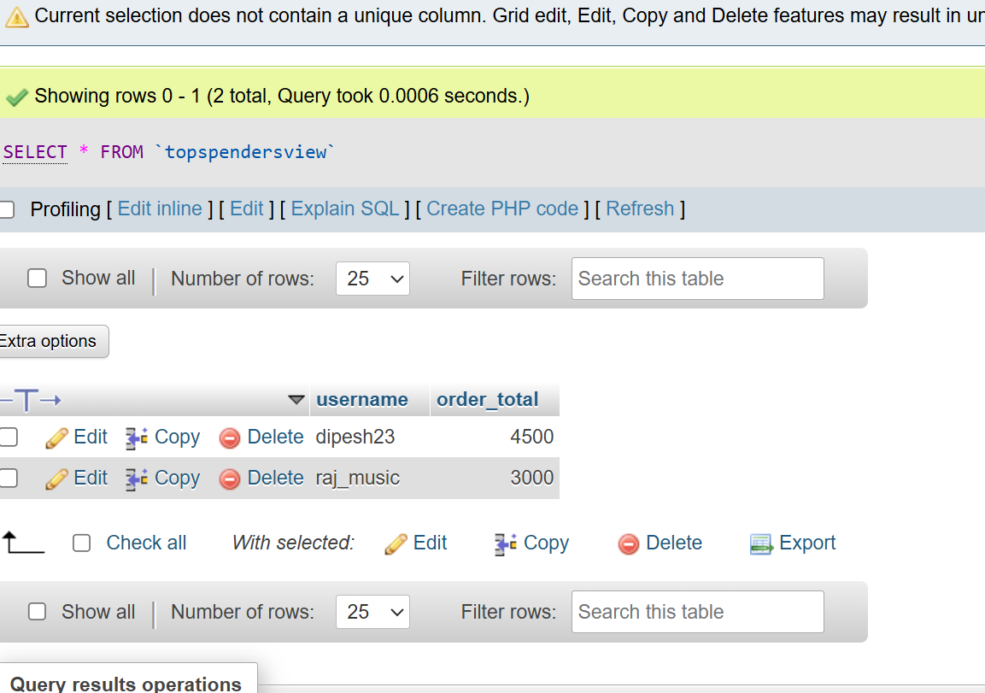
- SELECT * FROM `topspendersview` WHERE order_total > 1000;
